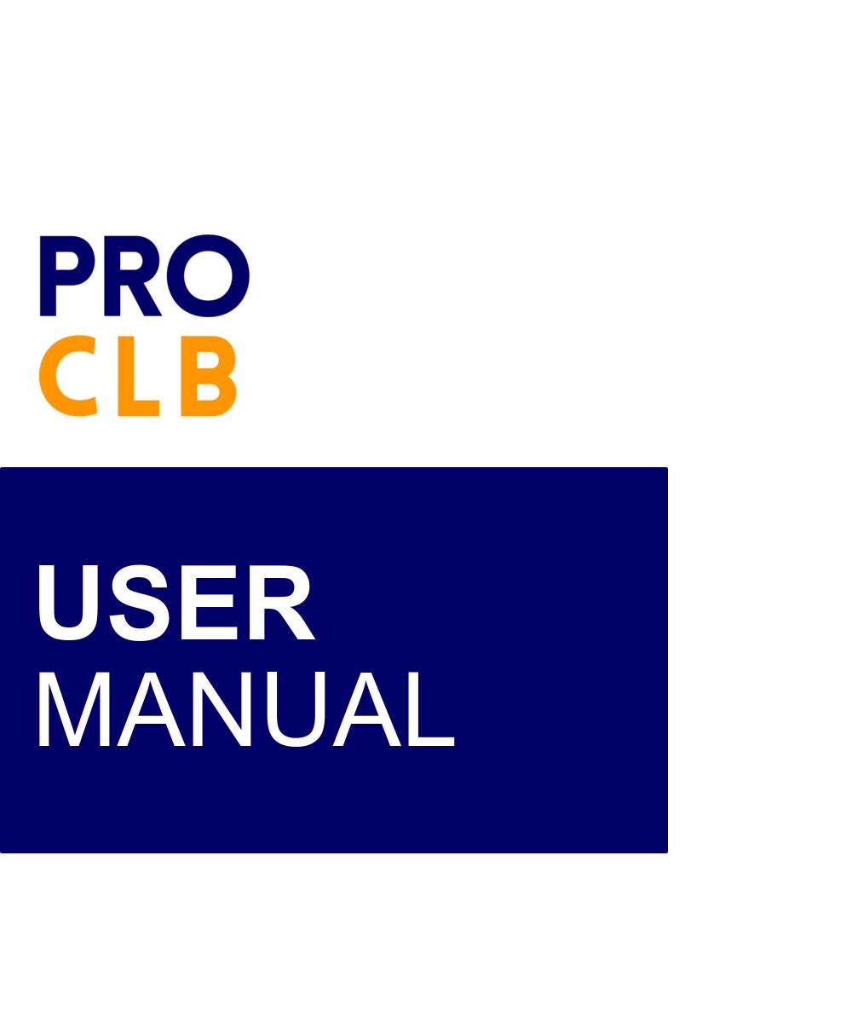

TABLE OF CONTENTS
SET-UP ACCOUNT AND LOGGING IN 3
Log-in PRO CLB. 3
Set-up (2FA) Two-Factor Authentication using mobile phone application. 3
USER PROFILE 4
Change Password 4
CREATION OF REQUEST 5
Create request in PRO CLB 5
Create a request in PRO CLB as Draft 6
Update a request in PRO CLB 6
Delete a request in PRO CLB (only for requests with Draft status). 7
View a request in PRO CLB 7
APPROVAL OR REJECTION OF REQUEST BY BU VALIDATOR 10
Approve or reject request in PRO CLB 10
APPROVAL OR REJECTION OF REQUEST BY BU PROPONENT 12
Approve or reject request in PRO CLB 12
APPROVAL OR REJECTION OF REQUEST BY BU APPROVER 14
Approve or reject request in PRO CLB 14
APPROVAL OR REJECTION OF REQUEST BY DMS VALIDATOR 15
RECEIVE REQUEST BY BU RECEIVER 16
Receive request in PRO CLB 16
DELEGATION OF REQUEST BY TASK DELEGATOR 17
Future Delegation 17
Delegate one or more multiple in-flight requests. 17
GENERATE REPORT 18
Generate report in PRO CLB 18

SET-UP ACCOUNT AND LOGGING IN

Log-in PRO CLB.
- You will receive an email notification containing your username and temporary password.
- Open your preferred browser, either Google Chrome or Microsoft Edge.
- Copy the URL/link for PRO CLB and paste it into the address bar of the browser.
- Click button to proceed.
- Enter your Username and Password, then click Log In to access. 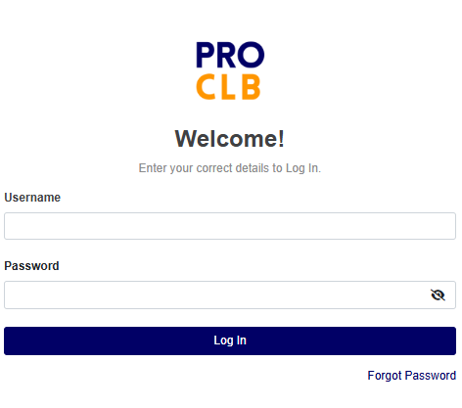

Set-up (2FA) Two-Factor Authentication using mobile phone application.
- For new user, open the App Store (for iPhone) or Google Play Store (for Android).

- Search for a mobile authenticator app. You can choose any of the following apps:
- Google Authenticator
- Authy
- Microsoft Authenticator
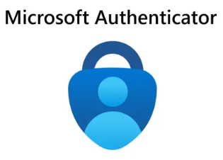
- Download and install the app of your choice on your mobile device.
- Open PRO CLB and log in to your account.
- In the 2FA setup screen, a QR code will be generated for you to scan.
- Open the Authenticator app on your mobile device.
- In the app, tap on the option to Add Account or Scan QR Code.
- Use your mobile device's camera to scan the QR code displayed in PRO CLB.
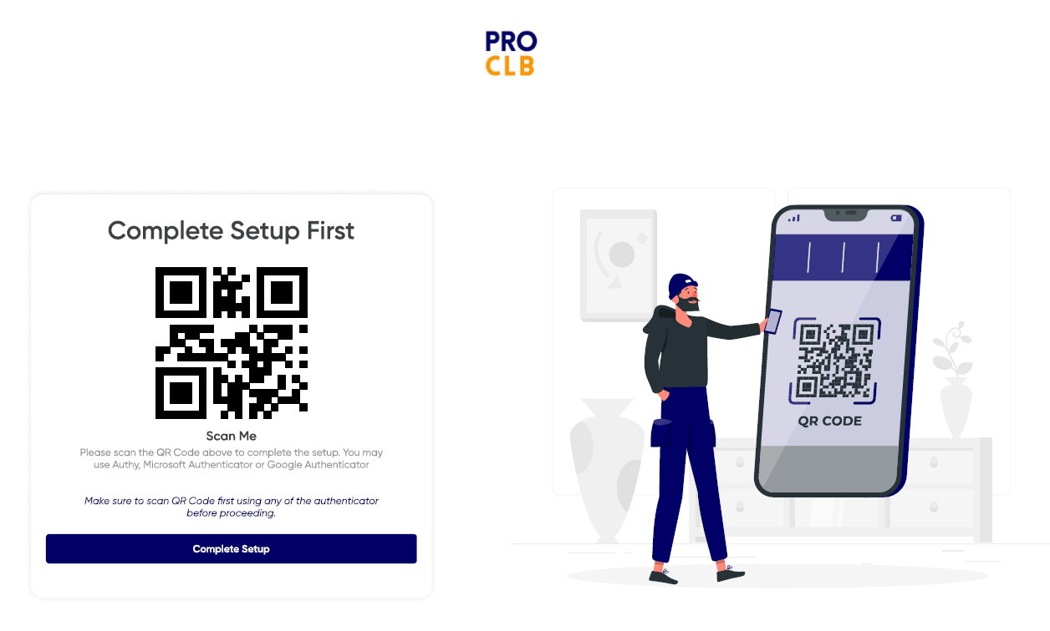
- Once scanned, the app will generate a 6-digit verification code that updates every 30 seconds.
- Click Complete Setup button to finalize the setup, then click Yes, I’m Done.
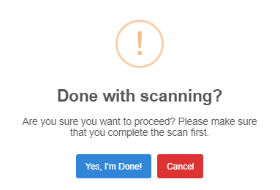

USER PROFILE

Change Password
- Click on the profile name located in the top-right corner.
- Under Security, input your current password, new password, and confirm new password.
- Click 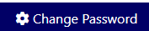 button.

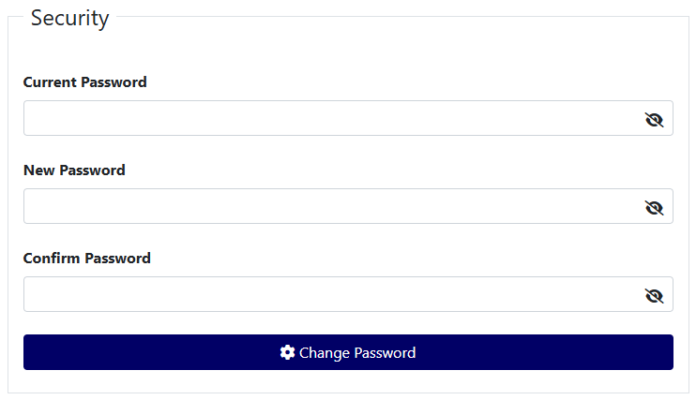

CREATION OF REQUEST

Create request in PRO CLB
- On the Side Panel, click on Create Request.
- Select the Request Type and Business Unit, then click Next to proceed.
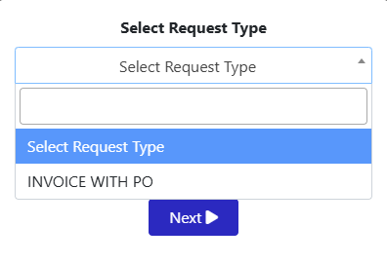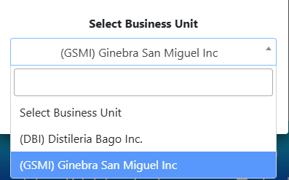
- Under Step 1: Input Request Details, enter the required information in the Request, and Invoice Details sections, ensuring that all (*) required fields are filled out. Then click Next.
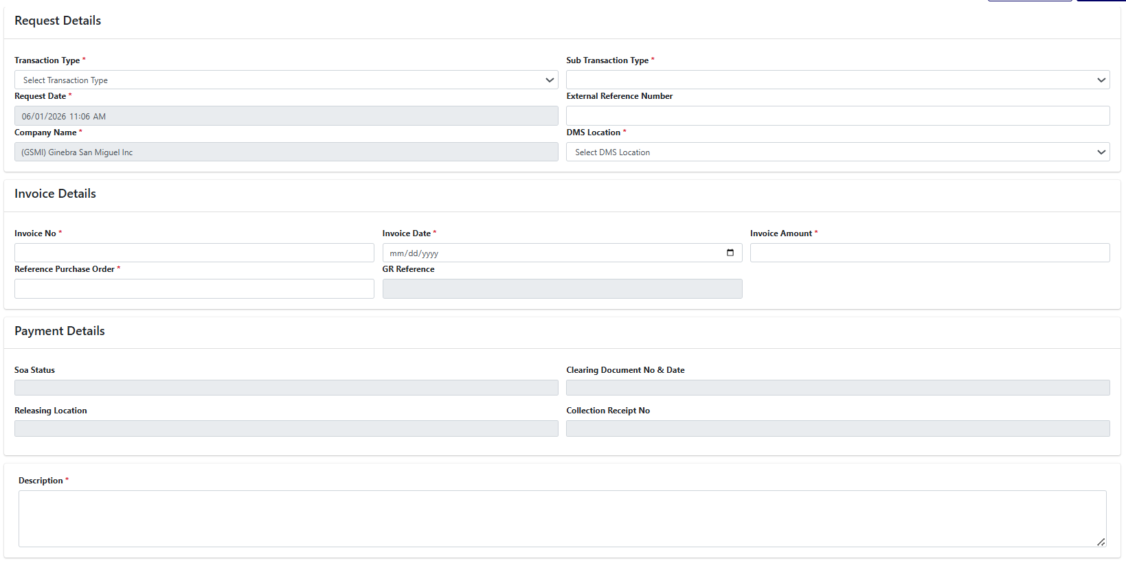
- Under Step 2: Attach/Upload the required supporting documents in PDF or excel format (Other formats will not be accepted), then click Next.
*Note: Scanning of required documents should be in sequence
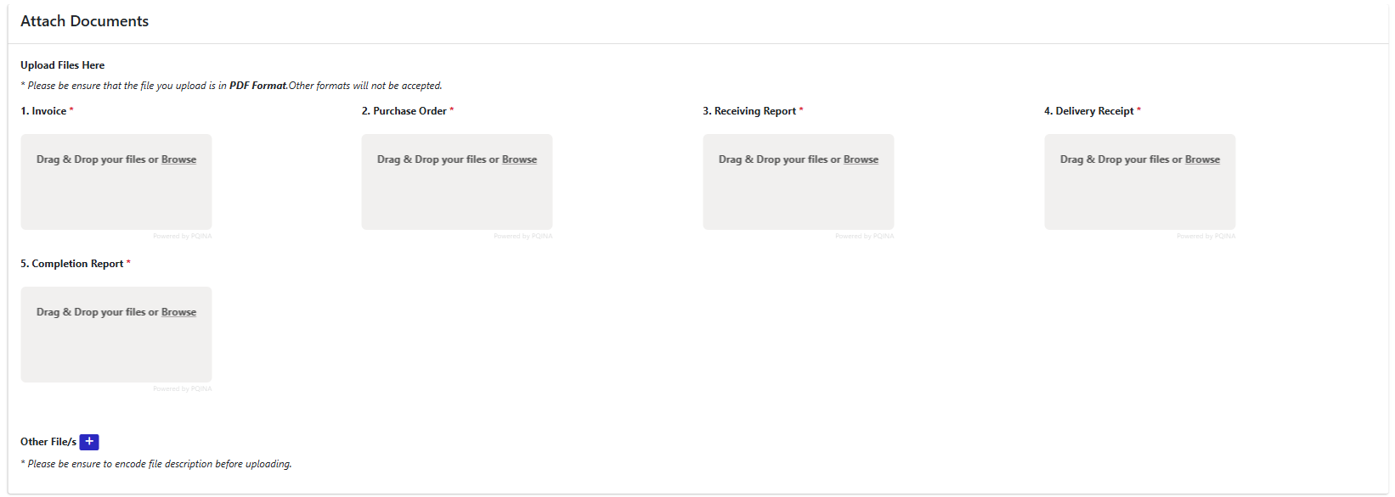

- Under Step 3: Verify all encoded information to ensure accuracy, then click Next.
- Under Step 4: the request will be submitted for review and approval. A request number will be generated for your reference.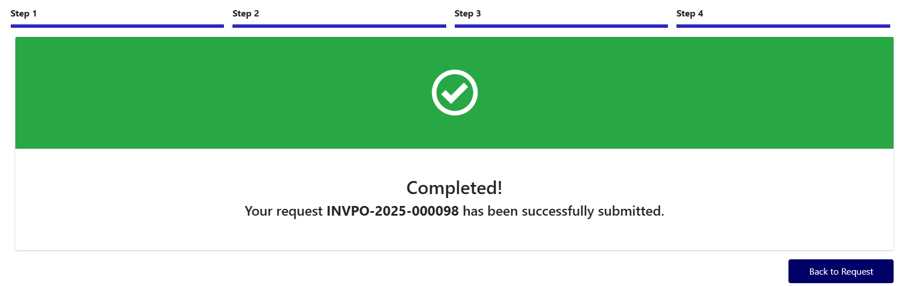

Create a request in PRO CLB as Draft
- On the Side Panel, click on Create Request.
- Select the Request Type and Business Unit, then click Next to proceed.
- Under Step 1: Input Request Details, enter the required information in the Request, and Invoice Details sections, ensuring that all (*) required fields are filled out. Then click Save as Draft or Next.
- Under Step 2: Attach/Upload the required supporting documents in PDF or excel format, then click Next.
- Under Step 3: Verify all encoded information to ensure accuracy, then click Save as Draft.

Update a request in PRO CLB
- On the Side Panel, you can search for a request either from the Dashboard or the Requests List.
- Select the desired Request and click Update button to proceed.
- Under Step 1: Update/Input Request Details, enter the required information in the Request, and Invoice Details sections, ensuring that all (*) required fields are filled out. Then click Next.
- Under Step 2: Attach/Upload the required supporting documents in PDF or excel format, then click Next.
- Under Step 3: Verify all encoded information to ensure accuracy, then click Next.
- Under Step 4, the request will be submitted for review and approval. A request number will be generated for your reference.

Delete a request in PRO CLB (only for requests with Draft status).
- On the Side Panel, you can search for a request either from the Dashboard or the Requests List.
- Select the desired Request and click Delete button.
*Note: Only requests with a Draft status can be deleted.
3. Click Yes.
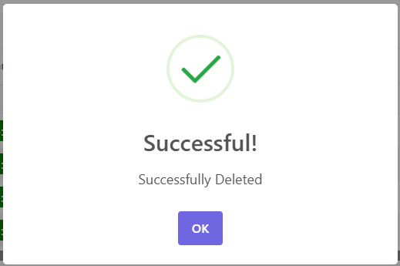

View a request in PRO CLB
- On the Side Panel, you can search for a request either from the Dashboard or the Request Register List.
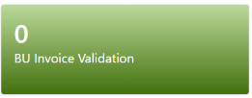
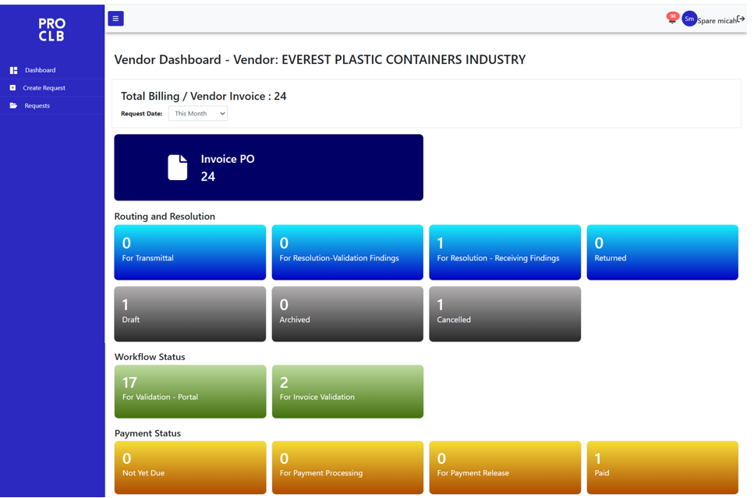
- Select the desired Request and click View button.
- You will be able to view the Request Details, Approval Workflow, Transaction Log, Workflow History and Event Logs information in their respective tabs.

Vendor Status Counter Panel
Routing and Resolution
  - For Transmittal – DV approved, ready for printing of transmittal slip, and physical documents ready for transmittal to DMS sites.
  - For Resolution-Validation Findings – Approver found issue; request returned for resolution.
  - For Resolution – Receiving Findings – Receiver found issue; request returned for resolution.
  - Returned – tagged as ‘With Issue-RTP’ (Returned to Proponent), request returned and rejected due to unresolved issues.

  - Draft - initial creation stage, request is being composed, editable and not yet submitted.
  - Archived – submitted request with pending issue for more than 30 days.
  - Cancelled – request was voided or withdrawn by the Vendor.
  - Resubmitted – Validation Findings – resubmitted requests after issue resolution.

Workflow Status
  - For Validation – Portal – submitted for review and approval of DMS Validator.
  - For Invoice Validation – queued for Accounts Payable team to validate and process invoice details.
  - BU Invoice Validation – submitted for review and approval of BU Validator, BU Proponent and BU Approver/s.
Payment Status
  - Not Yet Due - invoice is approved but not yet eligible for payment because of established payment terms.
  - For Payment Processing - invoice is due for payment processing.
  - For Payment Release - a check, LOA, or clearing document—is ready and awaiting release to or collection by the vendor.
  - Paid – payment has been released and confirmed by the payment processor; the vendor has been paid.

Others (PRO CLB)
  - In-Transit – For Receiving – physical documents have been dispatched and are currently
en route to receiving DMS locations.
  - Received – physical documents have arrived and been logged; the request is now approved for both physical and e-copy validation.
  - Resubmitted for Receiving – request is resubmitted for BU Receiver’s revalidation.
  - Completed – request has been fully processed, approved, and tagged as Paid.

Others (SYNQ SOA status)
  - For Validation and Approval – queued for DMT Encoding, AP Invoice Processing, AP Encoder Processing, and DV Approval.
  - DV Approved – AP team has processed the invoice, and the Disbursement Voucher has been approved. Request is now ready for transmittal.
  - With Issue - RTP – request tagged with issue for return to BU Proponent, with reason for returning, details of recipient and date of transmittal.
  - With Issue - FIR – request tagged with issue for internal resolution (SYNQ).

APPROVAL OR REJECTION OF REQUEST BY BU VALIDATOR

Approve or reject request in PRO CLB
- On the Side Panel, click on Dashboard or Requests to access the list of pending requests.
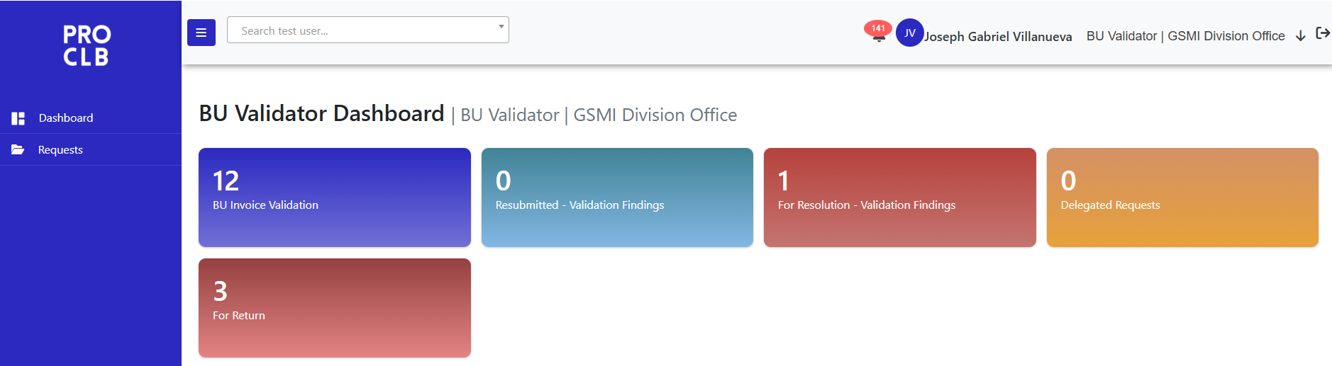
- Click on the desired status counter panel to display the list of corresponding requests.
- BU Invoice Validation – submitted requests for review and approval of BU Validator.
- Resubmitted – Validation Findings – BU Validator found issue; request resubmitted for revalidation.
  - For Resolution Validation Findings - BU Validator found issue; request returned for resolution.
  - Delegated Requests – requests that have been reassigned (delegated) to the BU Validator for review and approval.
  - For Return – requests have been tagged as "With Issue RTP," enabling the BU Validator to return the request to the vendor when necessary.
- Click View to open its details and attachments.
- If there are minor corrections, update the following fields:
  - Company Name
  - Invoice Number
  - Invoice Date
  - Invoice Amount
  - Reference PO
- Additional supporting documents may be uploaded as needed.
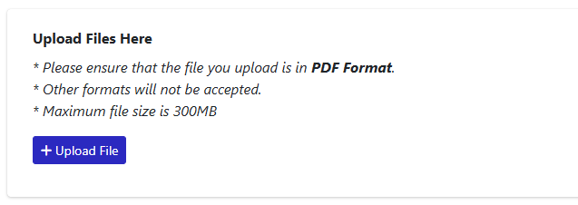
- For Approval: Click the  button, input Remarks if necessary (optional), then click +Add Adhoc Approver to assign a BU Proponent.

- Click Approve.
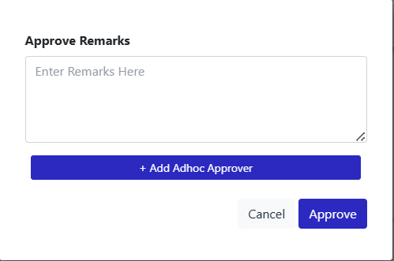
For Rejections: Click the  button, select Rejection Type from the dropdown menu and input Rejection Remarks in the provided field.
- Click Yes to proceed.

APPROVAL OR REJECTION OF REQUEST BY BU PROPONENT

Approve or reject request in PRO CLB
- On the Side Panel, click on Dashboard or Requests to access the list of pending requests.
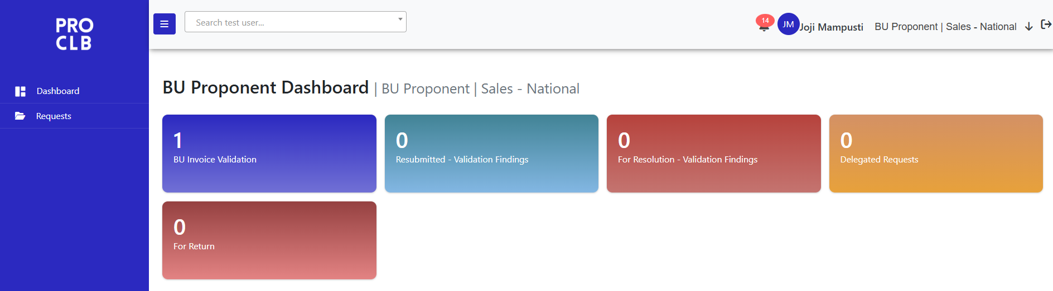
- Click on the desired status counter panel to display the list of corresponding requests.
- BU Invoice Validation – submitted requests for review and approval of BU Proponent.
- Resubmitted – Validation Findings – BU Proponent found issue; request resubmitted for revalidation.
  - For Resolution Validation Findings - BU Proponent found issue; request returned for resolution.
  - Delegated Requests – requests that have been reassigned (delegated) to the BU Proponent for review and approval.
  - For Return – requests have been tagged as "With Issue RTP," enabling the BU Proponent to return the request to the BU Validator when necessary.
- Click View to open its details and attachments.
- If there are minor corrections, update the following fields:
  - Company Name
  - Invoice Number
  - Invoice Date
  - Invoice Amount
  - Reference PO
- Input the required GR Reference and click Update Details. Additional supporting documents may be uploaded as needed.
- For Approval: Click the button, input Remarks if necessary (optional), then click +Add Adhoc Approver to assign a BU Approver L1.

- Click Approve.
For Rejections: Click the button, select Rejection Type from the dropdown menu and input Rejection Remarks in the provided field.
- Click Yes to proceed.

APPROVAL OR REJECTION OF REQUEST BY BU APPROVER

Approve or reject request in PRO CLB
- On the Side Panel, click on Dashboard or Requests to access the list of pending requests.
- Click on the desired status counter panel to display the list of corresponding requests.
- BU Invoice Validation – submitted requests for review and approval of BU Approver.
- Resubmitted – Validation Findings – BU Approver found issue; request resubmitted for revalidation.
  - For Resolution Validation Findings - BU Approver found issue; request returned for resolution.
  - Delegated Requests – requests that have been reassigned (delegated) to the BU Approver for review and approval.
- Click View to open its details and attachments.
- If there are minor corrections, update the following fields:
  - Company Name
  - Invoice Number
  - Invoice Date
  - Invoice Amount
- Additional supporting documents may be uploaded as needed.
- For Approval: Click the button, input Remarks if necessary (optional), then click +Add Adhoc Approver to assign a BU Approver L1.
- Click Approve.
For Rejections: Click the button, select Rejection Type from the dropdown menu and input Rejection Remarks in the provided field.
- Click Yes to proceed.

APPROVAL OR REJECTION OF REQUEST BY DMS VALIDATOR
- On the Side Panel, click on Dashboard or Requests to access the list of pending requests.
- Click on the desired status counter panel (e.g., Within, Beyond, Overdue) to display the list of corresponding requests.
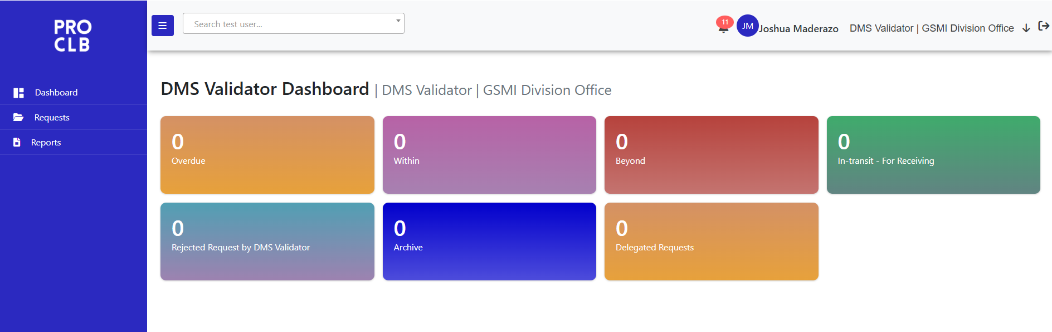
  - Overdue - request with ‘For Validation’ status and pending more than 24 hours from the time it was received ‘Within’.
- Within - request with ‘For Validation’ status, submitted previous date or later, and pending within 24 hours from the time it was submitted ‘For Validation’ based on 3PM cutoff.
- Beyond - request with ‘For Validation’ status and submission date are today and time is beyond cut-off time 3:01 PM.
  - In-Transit for Receiving – transmitted request for receiving by BU Receiver.
  - Rejected Request by DMS Validator – DMS Validator found issue; request returned for resolution.
  - Archive - request with ‘For Resolution – Validation Findings’ status and pending more than 30 days.
  - Delegated Request – request that has been assigned for approval on behalf of the original approver.
- Click View button to open its details and attachments.
- If there are minor corrections, update the following fields:
  - Company Name
  - Invoice Number
  - Invoice Date
  - Invoice Amount
  - Reference PO
- For Approvals: Click the button, input Remarks if necessary (optional), then assign a DMS Encoder in SYNQ.
For Rejections: Click the button, select Rejection Type from the dropdown menu and input Rejection Remarks in the provided field.
- Click Yes to proceed.

RECEIVE REQUEST BY BU RECEIVER

Receive request in PRO CLB
- On the Side Panel, click on Dashboard or Requests to access the list of pending requests.
- Click on the desired status counter panel to display the list of corresponding requests.
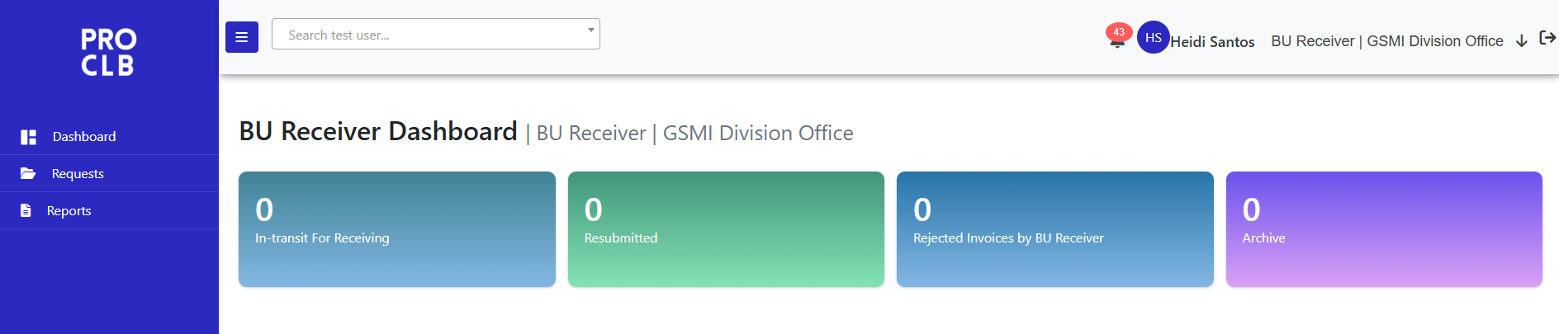
- In-Transit for Receiving - requests with ‘In-transit - For Receiving’ status.
  - Resubmitted – resolved request and resubmitted by vendor for receiving
  - Rejected Invoices by BU Receiver – BU Receiver found issue; request returned for resolution.
  - Archive – requests with ‘For Resolution – Receiving Findings’ status and pending more than 30 days.
- Click View button to open its details and attachments.
- For Approvals: Click the button, then input Remarks if necessary (optional).
For Rejections: Click the button, select Rejection Type from the dropdown menu and input Rejection Remarks in the provided field.
- Click Yes to proceed.

DELEGATION OF REQUEST BY TASK DELEGATOR

Future Delegation
- On the Side Panel, click on 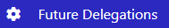.
- Click on Create Delegation.
- Select a Role - Choose the role for which the delegation is being created.
- Area/Department (Delegated From) – the current approver’s assigned area or department.
- Delegated From – the currently assigned approver.
- Area/Department (Delegated To) – the delegatee’s assigned area or department.
- Delegated To - the person authorized to approve requests during the delegation period.
- Validity From and To Date - defines the start and end dates of the delegation period.
- Click Submit.

*Note – Delegation Status
- For Processing – delegation is currently being processed in the background.
- Active - delegation is currently active and in effect
- Expired - delegation has passed its end date and is no longer valid.
- Cancelled - Delegation has been manually cancelled before the end date.
- Failed - delegation process was not completed successfully due to a system or validation error.

Delegate one or more multiple in-flight requests.
- On the Side Panel, click on .
- From the status counter panel, select Inflight Requests.
- Select the role and date for delegation.
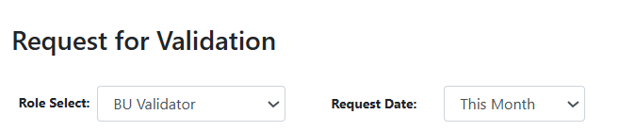
- Select one or more requests to delegate, then click.
- From the list, select the approver and end date. The currently assigned approver will be reflected in the table.
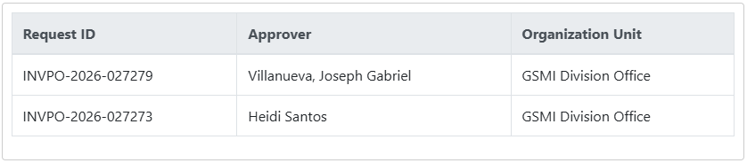
- Click Delegate.

GENERATE REPORT

Generate report in PRO CLB
- On the Side Panel, click on 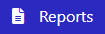 .
- Select Report Type from the dropdown list.
- Specify the date range, request type, business unit and location.
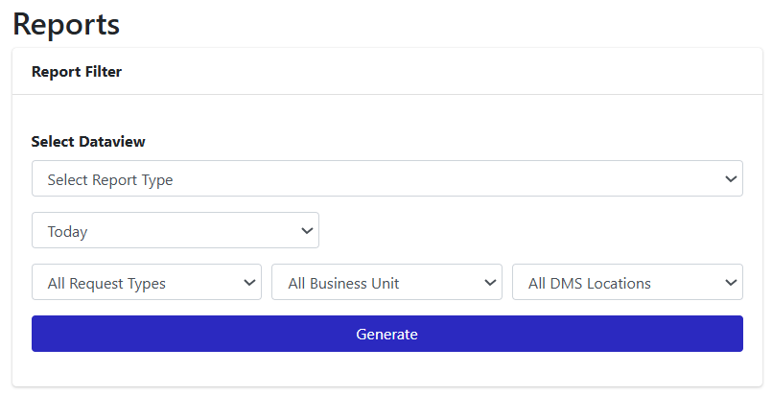
- Click Generate to create the report.
- User may have an option to filter by specific columns.
- To export the report, click the 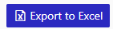button.

